IS2500 RFID Systems Homework 4 Name:

Question 1. This question has three parts:

You have been hired to design a radiative RFID system for a company that sells running shoes for professional athletes. The shoe company wants to have RFID in the shoe for quality control during manufacturing and for tracking the shoes as they are shipped to stores. You have designed a method for placing the RFID tag into the shoe between the bottom of the shoe and the wearer’s foot. A picture of your method is shown in figure 1 on the back of this page. The RFID reader used with this system has a carrier frequency of 2.4 Ghz and is intended to have a read range of 2 meters.

a) The RFID tag includes a half wavelength dipole antenna. What is the total wire length of this antenna? Show your calculations.

b) The CEO of your company is visiting your engineering group, and is looking at the tag with its half wavelength dipole antenna. The CEO does not think that the tag will work as a radiative RFID tag because to him the tag antenna looks very short. Do you agree with the CEO? Explain why or why not.

c) While you are showing your RFID solution to the athletic shoe company, one of their workers says that your design will violate the privacy of the person wearing the shoes. The worker says that a person wearing the shoes and running outside can be tracked by reading the RFID tag in the shoe. Do you think that the employee is right and that your RFID system is a significant privacy risk? Explain why or why not.

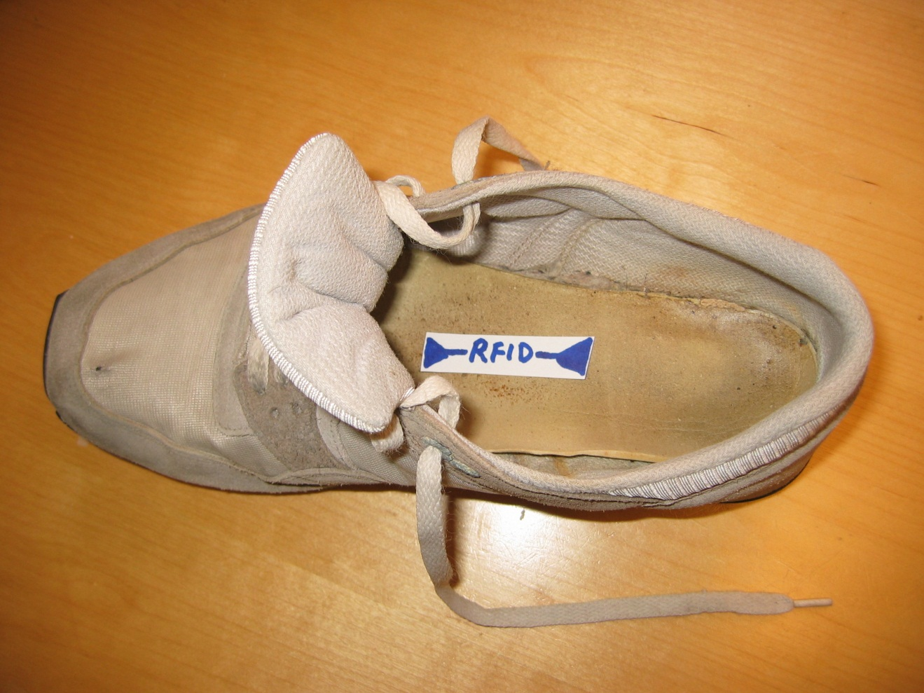
Figure 1: The RFID Athletic Shoe
Question 2: This question has 1 part.

Suppose you are given a RFID system that has the following characteristics:

a) The carrier frequency of the RFID reader is 920 Mhz.
b) The power requirement of the tag is 20 microwatts and the tag efficiency of converting RF energy into DC power is 33.3%
c) The forward link limited range is 3 meters.
d) The tag antenna’s effective aperture is 101.5 cm² at 920 Mhz.
e) The actual reader antenna is directional, and has a gain of 3 dBi.

What is the output power of the reader? Be sure to show your calculations.
Question 3. This question has two parts:

In the lab we have a RFID reader and tags that have the following characteristics:

- The reader operates at a carrier frequency of 900 Mhz.
- The output power of the RFID reader is 0.4 watts.
- We can attach any suitable antenna to the reader that we want.
- The tags are fully passive and use dipole antennas. We can assume they have an antenna gain of 2 dBi.

a) The local government where you will use the RFID system allows a RFID reader like this one to operate with an Effective Isotropic Radiated Power (EIRP) of 30 dBm. What is the maximum gain that an antenna we can attach to the reader can have? Express this gain in dBi and show your calculations.

b) Suppose we buy new tags for this system that have a tag antenna gain of 0 dBi. How does your answer to question 3a change?
Question 4. This question has two parts.

You are designing a RFID system that will be used in a large warehouse. The characteristics of the system are:

- The carrier frequency of the RFID reader is 920 Mhz.
- The RFID reader is a single conversion radio and uses a band pass filter to try filter out interference.
- The tags use FM0 modulation
- The tags send data back at a rate that at maximum is 400 kilobits/second.

a) The tags use FM0 modulation. Explain why using FM0 modulation is a good idea for the tag to use compared with simple on-off keying (OOK). Give at least two good reasons why FM0 is better and be sure to explain your answer fully.

b) What is the minimum band width the receiver needs to have to successfully read data from the tags? Show your calculations.

